Project Report: 3D Tanks Game

Game Title:
3D Tanks Game (Unity 3D)
Team Members:
- Mahmoud Amr – (320230087)
- Mohamed Adham – (320230001)
- Ahmed Hesham - (320230205)

2. Tools & Frameworks Used
The project was developed using the following tools and frameworks:
- Game Engine: Unity (2021.x LTS or newer)
- Programming Language: C# (MonoBehaviour scripts)
- IDE: Visual Studio
- Version Control: Git / GitHub
- Graphics API: DirectX / OpenGL (Unity default, platform dependent)
- Audio System: Unity Audio Source & Audio Listener
Assets Used:
- Tank 3D models
- Terrain and environment assets
- Particle systems for explosions
- Audio clips (engine sounds, firing, explosions)

3. Game Overview & Objective
Overview
The 3D Tanks Game is a third-person Multiplayer Unity-based action game where the player controls a tank in a battlefield environment. The game focuses on vehicle movement, turret rotation, projectile physics, and enemy interaction.
The 2 players navigate the tanks across the terrain, aims the turret, fires shells, and destroys enemy objects or targets.

Story / Objective
The objective of the game is to control a battle tank and eliminate the other tank while navigating the environment strategically.
Key Gameplay Elements:
- Movement: Driving and steering the tank using keyboard input
- Combat: Firing tank shells with realistic projectile motion
- Targeting: Independent turret and cannon rotation
- Survival: Avoiding enemy fire and obstacles

4. Graphics Techniques Used
This section explains the computer graphics concepts and algorithms applied in the game.

4.1 Camera Transformations
The 3D Tanks Game implements a third-person follow camera using Unity’s C# scripting system. The camera is designed to smoothly follow the player’s tank while maintaining a fixed distance and angle to provide a clear view of the battlefield.

Camera Technique Used
The camera follows the tank using a position offset technique, where the camera’s position is calculated relative to the tank’s transform. This approach ensures consistent framing of the player object during movement and rotation.

Implementation:
- Target Tracking
- The camera script references the tank GameObject as its target.
- Each frame, the camera updates its position based on the tank’s current transform.
- Offset-Based Positioning
- A Vector3 offset is defined to position the camera behind and above the tank.
- This offset remains constant to ensure stable viewing.
Vector3 offset = new Vector3(0, 5, -10);
- Frame Update Using LateUpdate()
- The camera logic is implemented inside LateUpdate() instead of Update().
- This ensures the tank’s movement is processed first, preventing camera jitter.
void LateUpdate() {
transform.position = target.position + offset;
}
- Rotation Alignment
- The camera rotates with the tank by aligning its rotation to the tank’s forward direction.
- This provides intuitive navigation and consistent player orientation.
transform.LookAt(target);
- Smooth Movement (Interpolation)
- Smooth camera motion is achieved using linear interpolation (Vector3.Lerp).
- This avoids sudden jumps when the tank changes direction
transform.position = Vector3.Lerp(
transform.position,
target.position + offset,
Time.deltaTime * smoothSpeed
);

Graphics Concepts Used:
- World-to-camera transformations
- Vector addition for camera offset
- Frame-based updates for smooth motion

4.2 Lighting
Unity’s built-in lighting system is used to enhance realism.
- Directional Light: Simulates sunlight and casts shadows.
- Real-time Shadows: Tanks and terrain cast dynamic shadows.
- Explosion Lighting: Light bursts are created during shell explosions.
- Ambient Lighting: Improves scene visibility and atmosphere.

4.3 Texture Mapping
- Materials: Standard Unity materials applied to tanks and terrain.
- UV Mapping: Pre-mapped tank models ensure correct texture placement.
- Terrain Texturing: Ground textures blended to create realistic terrain.
- Skybox: A skybox texture is used to represent the distant environment.

4.4 Shaders & Effects
- Particle Systems:
  - Shell explosions use particle effects for fire, smoke, and debris.
  - Dust particles appear when tanks move on terrain.
- Projectile Effects:
  - Shell firing includes muzzle flash particles.
  - Explosion effects are instantiated at collision points.
- Sound-Visual Sync:
  - Firing and explosion sounds are synchronized with visual effects.

4.5 Animations
- Tank Movement:
  - Wheel and track animations simulate realistic motion.
- Turret Rotation:
  - The turret rotates independently using transform rotation.
- Cannon Elevation:
  - Vertical rotation allows aiming up and down.
- State-Based Behavior:
  - Idle, moving, and firing states controlled via scripts.

- Screenshots of the Game

- Final score: 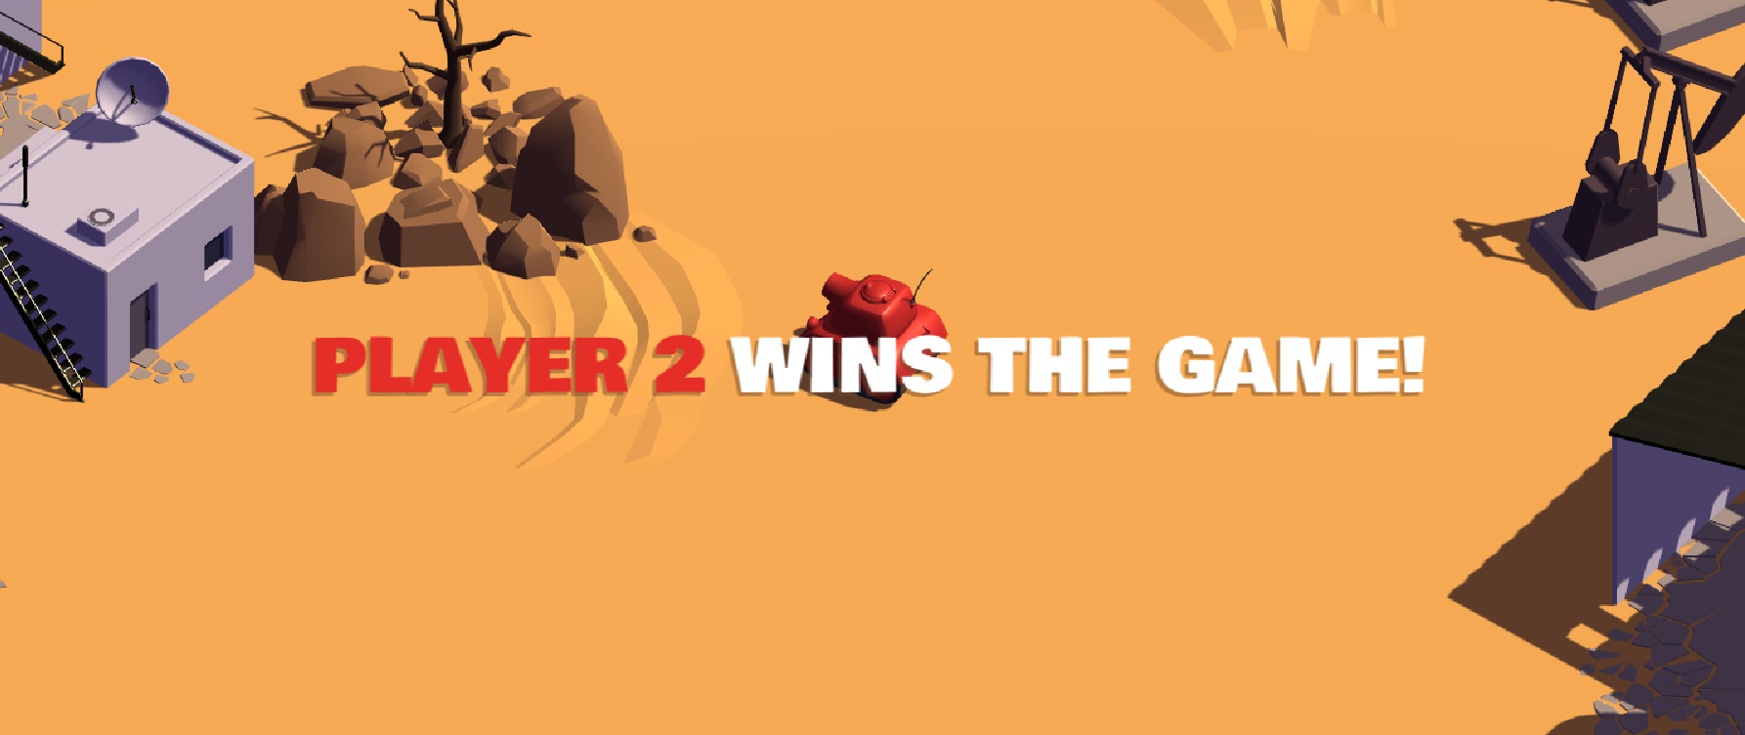
- Tank firing:
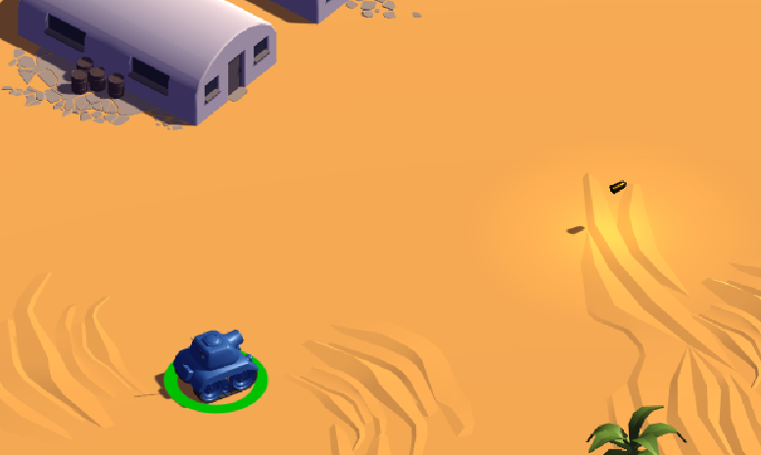

- Score update:
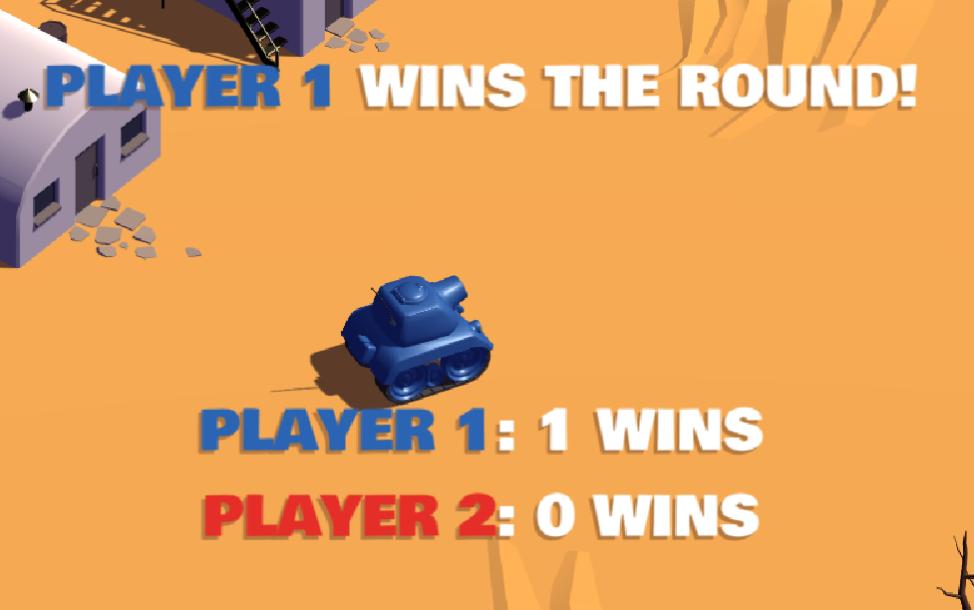

- Tank explosion:

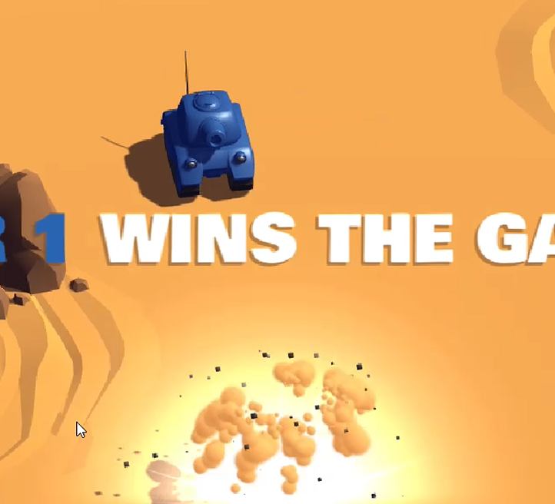
- Final score:
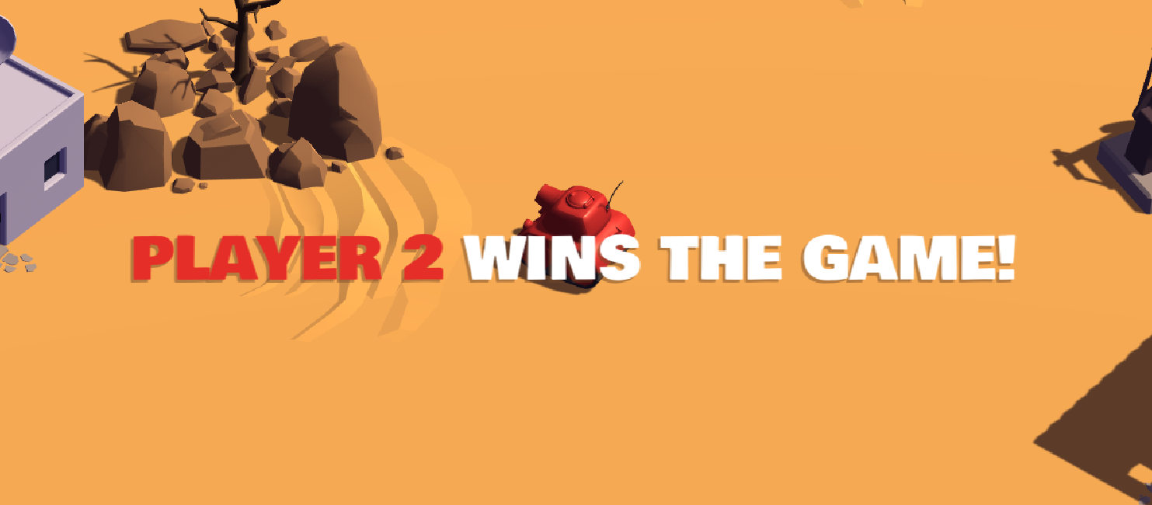

6. How to Run the Game
Prerequisites
- Install Unity Hub
- Install Unity Editor 2021.3 LTS or later
- Install Visual Studio for C# scripting

Steps to Run
- Open Unity Hub
- Click Add Project
- Select the folder:
3D-Tanks-Game-Unity-master
- Open the project
- Go to Assets/Scenes
- Open the main scene
- Press Play (▶)

Controls (Blue tank)
- W / S: Move Forward / Backward
- A / D: Rotate Tank
- Space: Fire shell
- Esc: Pause / Exit

Controls (Red tank)
- Up arrow / down arrow: Move Forward / Backward
- Left arrow / Right arrow: Rotate Tank
- Enter: Fire shell
- Esc: Pause / Exit

Conclusion
The 3D Tanks Game demonstrates core concepts of computer graphics, game physics, and real-time interaction using Unity. The project successfully applies camera transformations, lighting, texture mapping, particle systems, and animation techniques to create an engaging interactive experience.

